# ABSTRACT

NALWAYA, AKSHAY. Using Hoeffding Sampling and Project Elimination to make Bellwether discovery faster. (Under the direction of Dr. Timothy Menzies)

In software engineering, the project data is continuously updated and augmented. Prediction models build from these projects become increasingly varied as the number of projects increased and ultimately resulting in changing results. This problem of conclusion instability in software engineering can be mitigated by using *Bellwethers*. It helps to build quality software prediction models. This problem was extensively researched in paper Bellwethers. Bellwethers are used as a baseline method for transfer learning and then this baseline is used for comparing future models.

So, in this work, we explore alternative methods to make the task of identification of bellwethers project in a group of projects faster for the defect prediction domain. An *O(N2)* approach was presented in the Bellwethers paper and we try to explore the applicability of Hoeffdings bounds to sample the training set and experiment with various combinations in the train and test sets. In addition to sampling the dataset, we also try to prune projects which are unlikely to be a candidate for the bellwether project. Then we perform experiments with various feature selection algorithms with the aim to reduce the bellwether identification time and improve prediction model performance.

© Copyright 2018 by Akshay Nalwaya

# All Rights ReservedUsing Hoeffding Sampling and Project Elimination to make Bellwether discovery faster

by

Akshay Nalwaya

A thesis submitted to the Graduate Faculty of

North Carolina State University

in partial fulfillment of the

requirements for the Degree of

Master of Science

Master of Science – Computer Science

Raleigh, North Carolina

2018

APPROVED BY:

______________________________ _______________________________

Dr. Timothy Menzies Dr. Matthias Stallmann

Committee Chair

_______________________________

Dr. Vincent Freeh

# BIOGRAPHY

Akshay Nalwaya was born in a small town named Ratlam in India. He obtained his bachelor’s degree in Computer Engineering from Shri GS Institute of Technology and Science in 2016. After that, he joined Mu Sigma as a Decision Scientist. In 2017, Akshay started his master’s degree in Computer Science at NC State University and joined ABB as an Artificial Intelligence Intern after a year. To explore research in the areas of machine learning and data science, Akshay started working under the guidance of Dr. Timothy Menzies.

# ACKNOWLEDGMENTS

I would like to thank Professor Timothy Menzies for giving me an opportunity to work and explore Bellwethers phenomenon in software engineering projects and providing an introduction about various concepts of data mining for Software Engineering in general. I would also like to express my gratitude towards Rahul Krishna for helping at various times of need and providing guidance.

**TABLE OF CONTENTS**

LIST OF TABLES vii

LIST OF FIGURES viii

**Chapter 1: Introduction** 1

Bellwethers 1

Importance of bellwether identification 1

Defect Prediction 2

Research Questions 3

Statement of Thesis 4

Contributions 4

Structure of Thesis 5

**Chapter 2: Related Work** 6

**Chapter 3: Core Idea** 8

Proposed Solution 8

Hoeffding Bounds 9

Sampling using Hoeffding Bounds 10

Modifying Hoeffding Bounds to reduce time 11

Project Elimination 12

Feature Selection 14

Importance of Feature Selection 15

Forward Feature Selection 16

Backward Feature Elimination 17

Information Gain as a feature selector 17

Correlation-based feature selection 19

**Chapter 4: Experimental Design** 20

Dataset 20

Baseline Model 21

Model Evaluation 21

Standard Measures of Evaluation 22

Class Imbalance 23

**Chapter 5: Results** 25

RQ1: Can we predict which data set is Bellwether? 25

RQ2: Can we reduce the time to find bellwether by reducing the size of data? 26

RQ3: Does sampling data using Hoeffding bounds outperform project elimination? 28

RQ4: Does feature selection improve the performance of bellwether identification? 28

**Chapter 6: Conclusion** 30

Conclusion 30

Future Work 31

**References** 32

**LIST OF TABLES**

Table 4.1 Data points for each project in Jureczko 20

Table 5.1 Median G-Score values for different approaches for Bellwether prediction 25

Table 5.2 Comparing run-times of all approaches for Bellwether identification 27

Table 5.3 Percentage of data required for training on a project and testing on others using Hoeffding bounds 28

Table 5.4 Projects pruned during project elimination approach 28

Table 5.5 G-Scores from project elimination approach 28

Table 5.6 Comparison of various feature selection algorithms for ‘poi’ 29

Table A Data Dictionary 36

**LIST OF FIGURES**

Figure 3.1 High-level process flow of proposed approach for Bellwether identification 9

Figure 5.1 Median g-score for ‘poi’ was the highest among all projects 26

Figure 5.2 Average runtime values for Bellwether identification 27

Figure 5.3 Comparison of feature selection algorithms 29

**CHAPTER 1: INTRODUCTION**

Bellwethers

The *bellwether effect* described in Bellwethers[1] states that when a community works on software, then there exists one exemplary project, called the *bellwether*, which can make predictions for the others. The model built using a bellwether project can serve as a baseline model for constructing different transfer learners in various domains of software engineering.

Bellwethers use the concept of transfer learning. When there is insufficient data to apply data miners to learn defect predictors, transfer learning can be used to transfer lessons learned from other source projects to new projects. Suppose, there is a new project, so we wouldn't have enough data for it, to predict the defects. This is when we can use data from other projects to make predictions for new projects.

**Importance of bellwether identification**

If there is insufficient data, transfer learning can be used by data miners and they could use lessons learned from one project and apply them on another project. Since the probability of having a defective code and a non-defective code is not similar, the SE data is often imbalanced and difficult to get. In such cases, Bellwethers method presents a simple solution - instead of exploring all available data, find one data set that may offer a stable conclusion over a longer period. Bellwethers[1] shows the existence of such projects in SE data sets and strives to find them. It is true that bellwethers, with such simplicity, are always better than other complex algorithms used for similar applications. At the same time, it has been shown that bellwethers are capable of outperforming some of the more complicated algorithms.

Defect Prediction

The programs written for software engineering have various flaws. Every piece of code should be tested before addition to the main repository. The software can crash or malfunction if the code has defects. These parts of code that can lead to malfunction or even crash of application are called defects. Now, a possible solution to avoid defects is by testing the code beforehand. However, testing introduces a lot of additional expenses and sometimes the time taken for testing is similar to the time taken for developing that piece of code. This regards testing as a possible solution but not an optimum solution. Tim Menzies in his paper [2] correctly mentions that, the fundamental issue in cross project defect prediction is selecting the most appropriate training data for creating quality defect predictors. Another concern is whether historical data of open-source projects can be used to create quality predictors for proprietary projects from a practical point-of-view. Also these methods apply brute force techniques which are computationally expensive. Exponential costs exhaust the resources available and testing could be made less expensive, if only a part i.e., a critical section has to be tested.

There are various approaches to find such critical section in the code. For example, the defect predictions can be made using static code attributes. So, once the miner learns which section of code is most likely to have a defect, it can make predictions. Another method, although more time consuming is manually going through the code, which is more accurate. So, these methods can be used to guide which sections of code might have defects. The defect prediction models prioritize code review as well as testing resources, hence making them easier to use. Additionally, defect predictors often find the location of 70% (or more) of the defects in code.

**Research Questions**

* *RQ1: Can we predict which data set is bellwether?*

For identifying a Bellwether we take the Jureczko repository for defect predictions, we built a Random Forest Classifier using the approach mentioned in the Bellwethers[1] paper and compare these results with different sampling and elimination techniques as discussed in the subsequent sections. Based on the results obtained, we were able to find the Bellwether project and it was the same in all the different implementations. This also shows that there exists a project which can act as a predictor for all the other projects.

* *RQ2: Can we reduce the time to find bellwether by reducing the size of data?*

We tried different algorithms that explore the possibility of not requiring to test current project against every other project or to reduce the data instances required for training/testing. For this, we have applied Hoeffding bounds and project elimination. It was found that Hoeffding bounds reduced the bellwether identification time significantly by reducing the amount of training data needed. Then project elimination was implemented which also reduced the runtime by a fraction of *N*.

* *RQ3: Does sampling data based on Hoeffding sampling outperforms idea of project elimination?*

We studied the results obtained by the baseline model and established a threshold value for G-score that each project should satisfy to be considered for being a bellwether. This cut-off helped to eliminated certain projects that performed poorly for other projects. The time is taken by this project elimination approach was even lower than sampling techniques. The final G-score values were almost similar to those obtained by baseline and sampling techniques showing that without any loss in identification accuracy, we are able to reduce the run-time significantly.

* *RQ4: Does feature selection improve the performance of the bellwether identification?*

We implemented feature selection using algorithms that select a subset of features using information gain, and correlation. Also, we implemented forward and backward feature selection and performed a comparative study of their effect on bellwether prediction. It was found that the additional time taken by these approaches was not proportional to the improvement in g-score.

**Statement of Thesis**

Based on the experiments, it can be concluded that the current approach for finding bellwethers has high time complexity and can be reduced by using sampling techniques and project elimination.

**Contributions**

This work shows that by incorporating these concepts into bellwether identification approach the time complexity can be reduced without any compromise on the performance of the model. A new heuristic for project elimination has been proposed and implemented which takes use of the domain knowledge of the projects and determines the elimination threshold for eliminating projects. Feature selection is also incorporated to study the effect of various feature selection algorithms on the total runtime for bellwether identification.

**Structure of Thesis**

The rest of the thesis is organized as follows. Chapter 2 describes the work already done in this field and the merits/demerits of those approaches. Chapter 3 explains the core idea behind this thesis, the motivation behind it, followed by the algorithm proposed. Chapter 4 lays out the experimental design and the experimental trials performed. Chapter 5 presents the result of the experiments with respect to each of the research questions discussed above. Chapter 6 explains the results and the inferences that can be drawn from them.

**CHAPTER 2: RELATED WORK**

The current methodology of bellwether identification is an *O(N2)* algorithm that tends to evaluate each project against every other project. Though this is a simple process we believe that this approach needs investigation. In the current solution, data sets from a community are taken. Suppose we have 10 data sets, each data set is used for training a model. A model trained on a data set is tested on the remaining 9 data set. Relevant evaluation metric values are found. The model that makes the best predictions for most of the data set is found. The data set that was used to train this model is identified as Bellwethers. Evaluation metric generally used is G-score.

Identifying a bellwether project and using it for making predictions for the rest of the projects in that domain is a novel concept. This eliminates the need for training a model for each of the project for defect prediction. The time consumed for this approach would be very high as the number of projects keep on increasing. So, another approach that reduces the time complexity should be researched in order to make this algorithm applicable even when the number of projects increase.

It is important that the solution is scalable owning to the exponentially increasing data. This is issue is brought up by Zhang et. al. in their paper [3]. They mentioned, "Due to the large scale of the data being analyzed, analytic technologies such as machine learning techniques need to be scalable. The realization of scalability includes both the design and implementation of analytic technologies."

Predicting defective parts of the software that are more likely to contain defects. This effort is particularly useful when the project budget is limited, or the whole software system is too large to be tested exhaustively. A good defect predictor can guide software engineers to focus the testing on defect-prone parts of the software [5]. One method of predicting these defects could be using Bellwethers. Once we have the bellwethers data set, we can use it to predict defects for other projects. This will be extremely helpful not only when we there is no relevant amount of data for the new project but also, using just one data set and trained model we can predict defects for various projects.

For a high-performance defect predictor, researchers have been working on the choice of static attributes and effective learning algorithms since the 1990s [5]. The McCabe [6] and Halstead [7] metrics are widely used to describe the attributes of each software module (i.e. the unit of functionality of source code). In addition to seeking a better subset of attributes, choosing a good learning algorithm was shown to be at least equally important to the final performance [8]. Various statistical and machine learning methods have been investigated for SDP (Software Defect Prediction), among which Naive Bayes [8] and Random Forest [9], [10] were shown to have relatively high, stable performance [9], [11]. AdaBoost based on C4.5 decision trees was also found to be effective in some studies [12], [13].

Although bellwether identification used above is a simple process, we believe that this approach needs investigation. We can clearly see that the issue of runtime complexity remains an open issue and hence this thesis is to present another approach that can perform the same task with lower time complexity and without compromising the performance.

**CHAPTER 3: CORE IDEA**

Proposed Solution

As mentioned in the previous chapter, the current methodology of bellwether identification is an *O(N2)* algorithm that tends to evaluate each project against every other project. We aim to find a method that identifies a bellwether project in much lesser time without introducing any unnecessary complexity in the identification process. Also, it should be scalable when the number of projects is much larger than the ones explored in the current approach.

We can sample each data set to reduce the training or testing data set. This should lead to a significant reduction in the data set size, hence, reducing the time required to find the bellwethers. We performed various experiments with sampling the training and testing data sets. In addition to just sampling the data sets, we also compare this sampling method with the idea of eliminating a project altogether without having to test it on all the projects. For this we explored sampling methods available and zeroed on Hoeffdings bound method. This sampled the project data only till an improvement in the results can be obtained, this ensures that only required data points are chosen for training. This decreased the unimportant data points and hence lesser redundancy.

Sampling the training data would still require performing the training and testing on the sampled data set for each of the combination of projects in the repository. If we can eliminate some projects with low performance based on their performance in the initial stages, then it would give a much faster bellwether identification. This will reduce the number of projects that the algorithm will have to train the model on and hence would keep on shrinking the pool of candidate bellwether projects.

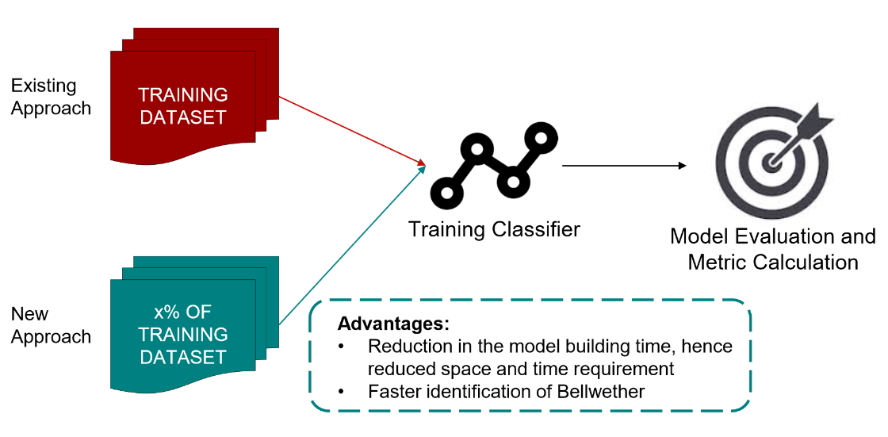

Figure 3.1 High-level process flow of proposed approach for Bellwether identification

**Hoeffding Bounds**

Let us say that we have *N* points with which to test a given model. If we were to test a model on all of them, then we would have an average error that we will call *Etrue*. However, if we only tested the model on ten points, then we only have an estimate of the true average error. We call the average after only *n* points *(n<N)* *Eest* since it is an estimate of *Etrue*. The more points we test on (the bigger *n* gets), the closer our estimate gets to the true error. How close is *Eest* to *Etrue* after *n* points? Hoeffding bound lets us answer that question when the *n* points are picked with an identical independent distribution from the set of *N* original test points. In this case, we can say that the probability of *Eest* being more than away from *Etrue*

where *B* bounds the greatest possible error that a model can make [16]. This bound does not make any assumptions other than the independence of the samples. The hoeffding racing algorithm was used for the test set originally.

Hoeffding racing algorithm has three major steps. It starts with each model known as the learning box. Learning box can be complex or time-consuming, we consider just the input and output of the model. The error is one of the most important metrics. Testing set is taken one data point at a time and data points are added. At each addition of data point, the error is calculated. So, firstly, compute the leave-one-out cross-validation error at each point of the test data set. The average error rate is updated at each iteration, as data points are added to the test data set. Using Hoeffding bound, we calculate how close is the average error rate to the original error rate. We can eliminate those learning boxes whose best possible error is still greater than the worst error of the best learning box. The point at which hoeffding bound is hit, we can break the loop. Racing algorithms basically, learn from the good models and eliminate the bad ones.\newline

Since racing never performs more queries than brute force, we formulated a strategy to use this in order to find Bellwethers. Also, the overhead involved in this process is negligible.

**Sampling using Hoeffding Bounds**

In this approach, our motive was to decrease the time required to find Bellwethers by decreasing the training data set. Each data set was taken, and the samples were added to the training data set. We start with 5% of the data set and at each iteration, 1% of the data is added. Model is trained on this data at each iteration and tested on the other projects. The point at which we are 95% confident that our estimate of the running g score is within the epsilon of baseline g-score is noted. The loop breaks for that test project and runs for all the remaining test projects. Once, we hit hoeffding bound for each test project, a similar exercise is run for the remaining projects. This helped us reduce the training data considerably.

However, the fraction of data being sampled for each test project was different. Hence, the time taken to run the process was not reduced. The fact that sampling the training data set for each test set was increasing the time of execution led us to devise another approach.

*Algorithm*

start time = current time

for project in projects

read data

for testproj in projects

if testproj not equal to project

sample data upto hoeffding bound

train random forest classifier

make predictions on testproj

calculate gscore

append g to a table

end time = current time

runtime = end time - start time

**Modifying Hoeffding bounds to reduce time**

In order to eliminate the time taken for sampling the training data differently for each data set, we took the maximum of the percentage of data required by any test project. This did not just decrease the training data set but impacted the time taken to find bellwethers. The time taken to find Bellwethers was reduced by 4 times.

In this approach, the sampling of data was done just once, and with the reduced training data set, predictions are made following the similar steps:

Firstly, each data set was taken, and the samples were added to the training data set. We start with 5% of the data set and at each iteration, 1% of the data is added. Model is trained on this data at each iteration and tested on the other projects. The point at which we are 95% confident that our estimate of the running *g-score* is within the epsilon of baseline *g-score* is noted. The loop breaks for that test project and runs for all the remaining test projects. Once, we hit hoeffding bound for each test project, a similar exercise is run for the remaining projects. Then, for each project, we consider the maximum amount of data required by any other test project. The training data is sampled according to the results from previous steps.

Bellwether prediction is done using the *g-scores* calculated according to the predictions made for each test data set. This helped us reduce the training data considerably as well as reduce the time by 4 times. *G-scores* calculated is almost similar to the values calculated through the baseline method.

*Algorithm*

start time = current time

for project in projects

read data

frac = get max % of training data

sample data for frac

train random forest classifier

for testproj in projects

if testproj not equal to project

make predictions on testproj

calculate gscore

append g to a table

end time = current time

runtime = end time - start time

**Project Elimination**

In the above experiments, we focused on using Hoeffding Bounds for efficiently sampling the data sets for all the projects. Depending on the approach, we experimented with sampling only the training data, or testing data, and then sampling both: training and testing data. The end goal was to try and reduce the number of records to be used for training and testing purposes. This doesn't reduce the number of projects, but it reduces the constant term in run-time complexity analysis, i.e., in *N2* the term *c* is reduced.

In this experiment, our objective was to explore if we can eliminate some projects and hence try to reduce the value of *N* in the complexity expression. We studied the baseline results for all the projects and found that some projects which consistently had low values for *G-score* for a prediction on other projects continued this trend for all the projects. This accounted for a large amount of time being spent on training and testing of projects that were not the candidates for bellwether. So, such projects should be eliminated without spending time using such projects for testing for all other projects.

Based on the baseline *G-score* values we decided a threshold value for the *G-score*. This threshold value should be satisfied for all the projects in order to be considered as a candidate bellwether project. The central value of *G-score* distribution for all the projects was chosen as the threshold value. Mean, median and mode are the most commonly used measures of central tendency. We chose the median as the representative value of the central tendency for bellwethers since mean is prone to be influenced by the presence of outliers in the data (*G-score* of projects in this case). One project with very low *G-score* could bring down the threshold *G-score* and lead to increased processing time. On the other hand, the median is not affected by some outliers in data, and hence is a better measure for this case.

Once this threshold was decided, we started with training a Random Forest Classifier on each of the projects. This trained random forest classifier is used for testing on all the other projects in a sequential manner. The G-score values for each iteration are recorded for each of the trained classifier models. The current project is eliminated if the following two conditions are satisfied:

1. *Condition 1:* Project is tested on at least 1/3rd of the projects
2. *Condition 2:* Mean of G-score value is less than the specified threshold value

All the projects satisfying these conditions are tested for the other projects until they violate these conditions, or it has been tested on all available projects. The projects violating these conditions are pruned and removed from the list of candidate bellwether projects. This serves as the early stopping rule to avoid testing on all projects and efficiently reducing the number of projects used for testing.

The *G-score* values are then aggregated for projects that have not been eliminated. The median value of *G-score* is taken and reported as the *G-score* for each project and the project with the highest mean value of *G-score* for testing on other projects is termed as the bellwether project for the given set of projects.

*Algorithm*

for each project do

load X_train, y_train

train random forest classifier

set threshold g-score

for all other projects

load X_test, y_test

make predictions

compute g-score

if eliminate-count > 2:

break

if g-score < threshold && #projects tested >= 3:

g-score = 0

append results, g-score

return results

**Feature Selection**

Although the above approaches reduce the time taken for Bellwether identification, we can try to reduce the time further by using feature selection techniques. Currently, we use the random forest classifier for building the classification model and it generates an ensemble of decision trees during the training phase. The final prediction by the model is based on the collective predictions from all these trees generated during the intermediate phase. This avoids overfitting in this classifier and incorporates feature selection.

Feature selection can be defined as the process of choosing a minimum subset of M features from the original set of N features so that the feature space is optimally reduced according to certain evaluation criterion. Feature selection reduces the dimensionality of feature space, removes redundant, irrelevant, or noisy data. It brings the immediate effects for application: speeding up a data mining algorithm, improving the data quality and thereof the performance of data mining, and increasing the comprehensibility of the mining results. [18]

We thought of using feature selection techniques into the approach with the objective of improving the performance of the system and reducing the time taken for the identification of bellwether project. Since only a subset of features will be present in the training data, the runtime for training the model should decrease.

**Importance of Feature Selection**

The main idea behind feature selection is to keep the relevant features in the data while removing the irrelevant features. This is done because the irrelevant attributes can degrade the performance of the model and they give no information about the final class variable to be predicted. Some of the key advantages of using feature selection are:

* Reduction in overfitting since predictions would now be made based on important features
* Improves the performance of the model
* Since training data reduces, training time decreases

Because of all these advantages offered by feature selection, we chose a few feature selection algorithms and analyzed their effect on the overall time and performance of the system.

* Forward Feature Selection
* Backward Feature Elimination
* Information Gain as a feature selector
* Correlation-based feature selection (CFS)

**Forward Feature Selection**

This is a feature selection approach where features are added to the selected subset of features one-by-one in each iteration until the addition of that features gives an improvement in the model. This process is iterative and it begins with an empty set in which we start with one of the features from the set of all features available in the data. Next step is to train a classifier model and measure its performance. The model evaluation metric, g-score in this case, is calculated. Now, another feature is selected from the set of features and added to this subset. The same process is repeated and the new g-score is compared with the previous g-score. The process stops when the new g-score value is lower than the previous g-score value indicating that the model performance has started degrading and the current subset of features is selected.

**Algorithm:**

create empty feature_subset

while (feature_subset does not contain all features):

add another feature to feature_subset

train random forest classifier on feature_subset

make predictions

calculate the g_score and store as new_gscore

if new_score < old_score:

break

old_score = new_score

return feature_subset

**Backward Feature Elimination**

This feature selection approach works in the opposite way as compared to the forward feature selection approach. In this approach, we start with a set containing all the features from data and keep on iteratively removing the features until the performance of the model improves. The terminating condition of this iterative process is the same as the forward selection approach. The rationale for this approach was that forward selection might stop early if the performance degrades but some important features might not have been used till now. This is because of the sequential manner of operation of these approaches.

**Algorithm:**

create feature_subset having all the features

while (feature_subset is not empty):

remove a feature from feature_subset

train random forest classifier on feature_subset

make predictions

calculate the g_score and store as new_gscore

if new_score < old_score:

break

old_score = new_score

return feature_subset

**Information Gain as a feature selector**

Both forward selection and backward elimination algorithms proceed in a sequential manner and hence, might terminate while encountering one or few of the irrelevant features. This will result in a suboptimal subset of features being selected by the algorithm. But, if we use information gain as a metric for feature selection [2], it ensures that features are selected in order of their information gain value.

It is one of the fastest methods for feature selection because we are not required to train the classifier model at each iteration, rather we compute the information gain for all attributes and then make a selection of feature subset. Once this feature subset is selected, the classifier model is trained on the data.

*Entropy and Information Gain:* **Entropy** of an attribute is the measure of its degree of randomness in a set of data points. The amount by which the entropy of the class decreases reflects the additional information about the class provided by the attribute and is referred to as the **information gain**. [2]

Mathematically,

$$H\left(C\right)=-\sum_{c ∈ C}{p(c)\log_{2}{p(c)}}$$

$$H\left(C | A\right)=-\sum_{a ∈ A}{p(a)}\sum_{c ∈ C}{p(c|a)\log_{2}{p(c|a)}}$$

where, H(C) represents the entropy of class C,

H(C|A) represents the entropy of class C given attribute A.

Information gain for each attribute is calculated using,

$${IG}_{i}=H\left(C\right)-H(C|A_{i})$$

$$=H\left(A_{i}\right)-H\left(A_{i}|C\right)$$

$$=H\left(A_{i}\right)+ H\left(C\right)-H\left(A_{i},C\right)$$

where, *IGi* represents the information gain for attribute *Ai*.

**Algorithm:**

Calculate info. gain for all attributes w.r.t. class variable

importance = list of information gain values

set threshold value as 50% of highest information gain

for all features:

if info. gain > threshold:

add it to feature_subset

return feature_subset

**Correlation-based feature selection (CFS)**

The main approach that differentiates CFS from all the algorithms discussed above is that it evaluates a subset of attributes rather than evaluating each attribute individually. This ensures the consideration of the level of inter-correlation between attributes while choosing the optimal subset during feature selection. A score is assigned to each candidate subset of attributes which is called *merit*. For a subset *S*, the value of *merit* is calculated as,

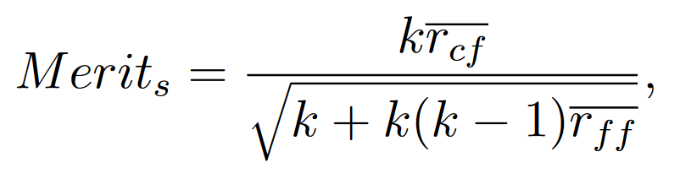

where, *k* is the number of features,

$\overline{r_{cf}}$ is the average feature-class correlation,

$\overline{r_{ff}}$ is the average feature-feature inter-correlation,

Based on this heuristic, CFS would assign high scores to subsets with attributes having a high correlation with class label and low inter-correlation with each other.

**CHAPTER 4: EXPERIMENTAL DESIGN**

Dataset

We limited our work to finding Bellwethers for defect measures we relied on data set gathered by Jureczko [17]. The data set contains defect measures from several Apache projects. The data set comprises data from 10 different projects. This data set contains records the number of known defects for each class using a post-release bug tracking system. The classes are described in terms of 20 metrics. Each data set in the Apache community has several versions. We merged data set across different version to create a bigger data set.

Following are the details of the data set for each project. All projects had 20 features. Since the class variable was continuous, we performed pre-processing to convert it to binary. This was done because our objective was to find whether for a given instance, will it have a bug or not and not the number of bugs identified. So, we mapped all the instances having at least 1 bug as a positive class (1) while those not having any bug as the negative class (0).

|  |  |
| --- | --- |
| **Project** | **Data Points** |
| ant | 1692 |
| camel | 2784 |
| ivy | 704 |
| jedit | 1749 |
| log4j | 449 |
| lucene | 782 |
| poi | 1378 |
| velocity | 689 |
| xalan | 3320 |

Table 4.1 Data points for each project in Jureczko

**Baseline Model**

There are many binary classifiers to predict defects, the Bellwethers [1] cites studies on defect prediction and follows the use of Random Forests for defect prediction over several other methods. For the sake of simplicity and effective comparison (if required) we decided to use the Random Forest Classifier.

Baseline calculation is a straight forward task - for each project in the community *train* the model and *test* it against every other project and compute *g-scores* for each of the test iterations. The project with the best median value of the *g-score* is declared the Bellwether.

***Algorithm***

start time = current time

for project in projects

read data

train random forest classifier

for testproj in projects

if testproj not equal to project

make predictions on testproj

calculate gscore

append g to a table

end time = current time

runtime = end time - start time

**Model Evaluation**

The data set under consideration has binary class labels, with the records belonging to either the positive or negative class. The instances of projects having defects (one or more) are assigned a positive class while those without defects are assigned negative class implying no defect was found in that instance.

There are various metrics that can be derived from the confusion matrix obtained as a result of testing the classifier on each of the projects. Different measures of model evaluation are summarized below:

***Standard Measures of Evaluation***

* *Accuracy* – It is the percentage of instances of the data set that have been classified correctly by the model. It emphasizes on correct classification of both positive and negative classes equally. The mathematical formula for accuracy is,
$$accuracy= \frac{true positive+true negative}{total number of instances}$$

* *Precision* – It talks about how precise your model is, meaning it shows what fraction of instances that are predicted positive, are actually positive. Hence, a model with low precision would imply that either a there was a large number of false positives in the model or the number of true positives was very low.
$$Precision= \frac{true positive}{true positive+false positive}$$

* *Recall* – It calculates how many of the actual positive instances have been correctly captured by the model (true positives). It is also denoted by *pd* or the *probability of detection*.
$$Recall=\frac{true positive}{true positive+false negative}$$

* *False Alarm* – As the name suggests, this metric gives the percentage of negative instances that were erroneously predicted as positive instances. It is also denoted by *pf*.

$$pf=\frac{false positive}{false positive+true negative}$$

Each of the metrics we discussed above is used for model evaluation depending on the application and the type of data. For instance, if one aims to increase the recall for a model, then it might also increase the false alarm (pf) of the model. Similarly, there is a kind of inverse relationship present in between precision and recall. If one tries to increase the precision of a model, then the recall might have to be compromised with.

**Class Imbalance**

Class Imbalance in classification problems is a scenario where classes are not represented equally. Most classification data sets do not have an equal representation of the classes and often such class imbalance needs careful handling. Slight variations in the class distributions can be ignored but a significant variation needs to be taken into account.

There are several ways of handling class imbalance and most common among them are:

* Collect more data
* Change performance metric
* Re-sampling data set

*Why not choose accuracy for model evaluation in case of data with class imbalance?*

In the cases discussed above, accuracy can often be misleading. At times it may be desirable to select a model with a lower accuracy because of better predictive power on the problem. This issue is also explained Sokolova et. al. in their paper [4]. They mention, "the most used empirical measure, accuracy, does not distinguish between the number of correct labels of different classes."

For example, in a problem where there is a large class imbalance, a model can just predict the value of the majority class for all predictions and achieve a high classification accuracy, the problem is that this model is not useful in the problem domain.

*Model evaluation metric for class imbalance : G-Score*

We use the *g-score* [14] [15] as a metric for evaluating performance of classifier in this case of class imbalance. It combines *recall (pd)* and *false alarm rate (pf)*. The Bellwethers [1] cites studies which suggest that such a measure is justifiably better than other measures when the data set has imbalanced distribution in terms of classes. Hence, we are using G-Score in this paper as well. G-Score is measured as follows:

$$G=\frac{2*pd*(1-pf)}{(1+pd-pf)}$$

For example, in a problem where there is a large class imbalance, a model can just predict the value of the majority class for all predictions and achieve a high classification accuracy, the problem is that this model is not useful in the problem domain.

**CHAPTER 5: RESULTS**

***RQ1: Can we predict which data set is Bellwether?***

We can predict bellwethers using the baseline method, and this method generates *g-score* values. It should be noted that the value of *g-score* for all the approaches discussed in this paper is very similar.

The bellwether data set can be predicted using the *g-score* and *poi*, proves to be the data set with the best *g-score*. However, *xalan* and *lucene* have median *g-score* comparable to that of *poi*. We implemented three different approaches to predict Bellwethers and for all the three approaches, *poi* has the highest g-score throughout.

|  |  |  |  |
| --- | --- | --- | --- |
| **Project** | **Baseline Approach** | **Hoeffding Bound** | **Modified Hoeffding Bound** |
| ant | 0.18 | 0.18 | 0.19 |
| camel | 0.24 | 0.25 | 0.24 |
| ivy | 0.09 | 0.12 | 0.12 |
| jedit | 0.04 | 0.03 | 0.04 |
| log4j | 0.34 | 0.34 | 0.32 |
| lucene | 0.52 | 0.52 | 0.51 |
| **poi** | **0.61** | **0.62** | **0.61** |
| velocity | 0.49 | 0.49 | 0.49 |
| xalan | 0.56 | 0.58 | 0.57 |
| xerces | 0.42 | 0.43 | 0.43 |

Table 5.1 Median G-Score values for different approaches for Bellwether prediction

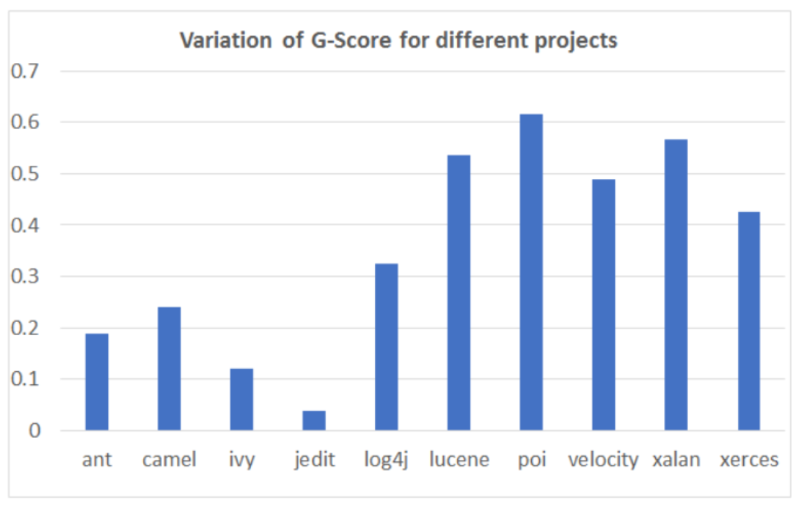

Figure 5.1 Median g-score for 'poi' was the highest among all projects

***RQ2: Can we reduce the time to find bellwether by reducing the size of data?***

For research question 2, we found the point when hoeffding bound is hit. Instead of the whole training data set, only a percentage of the data set sample can be taken. The results are shown in the table below. All results were calculated after running for 30 iterations.

The data for training can be reduced a lot but sampling the data, again and again, consumes a lot of time. Hence, we took the maximum amount of training data required to hit the hoeffding bound for any test project and sampled training data accordingly. The sampling of data for each training set is just done once, considerably reducing run time. The results show that the run time has reduced more than 4 times. Tables below show the percentage of data used for training, their updated G-score and the runtimes for each approach.

|  |  |  |
| --- | --- | --- |
| **S. No.** | **Experiment** | **Time Taken (in sec)** |
| 1 | Baseline Approach | 199.32 |
| 2 | Hoeffding Sampling | 211.57 |
| 3 | Modified Hoeffding Sampling | **44.16** |
| 4 | Project Elimination | **34.63** |

Table 5.2 Comparing run-times of all approaches for Bellwether identification

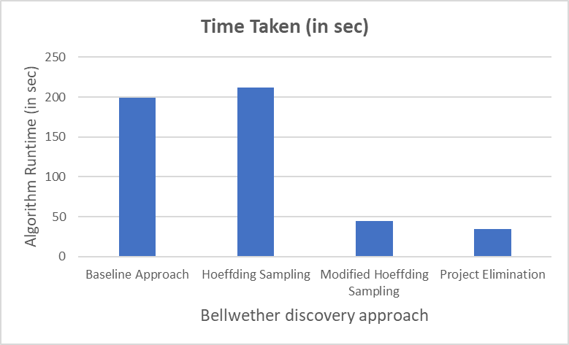

Figure 5.2 Average runtime values for Bellwether identification

|  |  |  |  |  |  |  |  |  |  |  |
| --- | --- | --- | --- | --- | --- | --- | --- | --- | --- | --- |
| **Trained on** | **Tested on** | | | | | | | | | |
| **ant** | **camel** | **ivy** | **jedit** | **log4j** | **lucene** | **poi** | **velocity** | **xalan** | **xerces** |
| ant | - | 5 | 6 | 7 | 8 | 9 | 10 | 11 | 12 | 13 |
| camel | 5 | - | 6 | 7 | 8 | 9 | 10 | 11 | 12 | 13 |
| ivy | 5 | 6 | - | 7 | 8 | 9 | 10 | 11.5 | 12 | 12.5 |
| jedit | 5 | 6 | 7 | - | 8 | 9 | 10 | 8 | 12.5 | 12 |
| log4j | 5 | 6 | 7 | 8 | - | 9 | 10 | 11 | 12 | 13 |
| lucene | 5 | 6 | 7 | 8 | 9 | - | 10 | 11 | 12 | 13 |
| poi | 5 | 6 | 7 | 8 | 9 | 10 | - | 11 | 12 | 13 |
| velocity | 5 | 6 | 7 | 8 | 7 | 10 | 11 | - | 12 | 13 |
| xalan | 5 | 6 | 7 | 8 | 8.5 | 10 | 11 | 12 | - | 13 |
| xerces | 5 | 7.5 | 7 | 8 | 8 | 9.5 | 11 | 12 | 13 | - |

Table 5.3 Percentage of data required for training on a project and testing on others using Hoeffding bounds

***RQ3: Does sampling data based on Hoeffding bounds outperforms idea of project elimination?***

All results were calculated after running for 30 iterations. Based on the values of average run times in figure 5, it is evident that eliminating projects definitely reduces the time required for finding bellwether project when compared with the baseline run time obtained by round robin training of all projects against every other project. In addition to beating the run-time of the baseline method, project elimination proved to be even better than sampling data using Hoeffding bounds.

|  |  |  |  |  |
| --- | --- | --- | --- | --- |
| Projects Eliminated | | | | |
| ant | camel | ivy | jedit | log4j |

Table .4 Projects pruned during project elimination approach

|  |  |
| --- | --- |
| **Project** | **G-Score** |
| Lucene | 0.54 |
| **Poi** | **0.61** |
| Velocity | 0.49 |
| Xalan | 0.57 |

Table 5.5 G-Scores from project elimination approach

***RQ4: Does feature selection improve the performance of the bellwether identification?***

Among the feature selection algorithms implemented, information gain based feature selection is the fastest while correlation-based feature selection is the slowest. Information gain based feature selection is fastest because it calculates the information gain for all attributes before starting with training the classifier and hence does not involve iterative training of a classifier model. The results obtained using the inbuilt feature selection approach in Random Forest classifier are better than the other feature selection algorithms in most of the cases, but if not, it’s still almost equivalent to the best feature selection algorithm results that require much more computational time. Hence, it is better to go with the default feature selection in Random Forest classifier rather than performing feature selection explicitly before training the model.

|  |  |  |
| --- | --- | --- |
| **Feature Selection Approach** | **g-Score** | **Runtime (in sec)** |
| Forward Feature Selection | 0.62 | 2.22 |
| Backward Feature Elimination | 0.63 | 5.07 |
| Information Gain | **0.58** | **1.34** |
| CFS | **0.58** | **12.12** |
| None | **0.61** | **1.42** |

Table 5.6 Comparison of various feature selection algorithms for ‘poi’

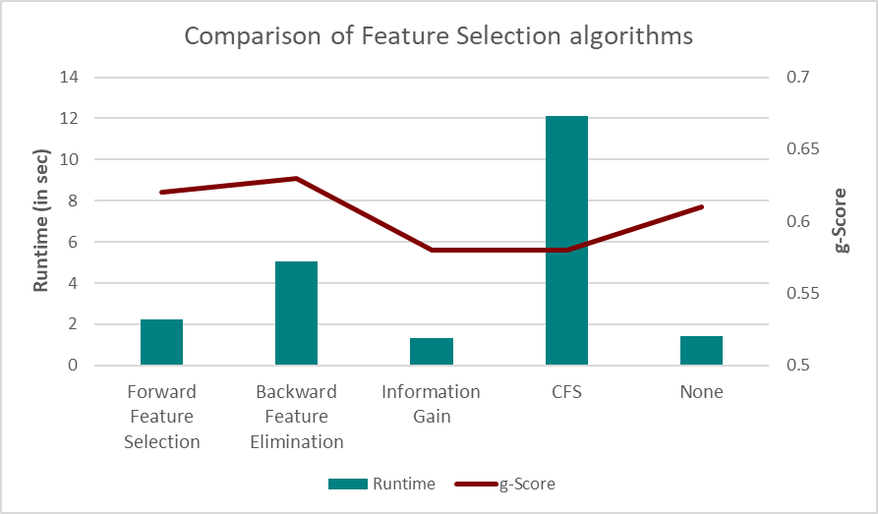

Figure 1 Comparison of feature selection algorithms

**CHAPTER 6: CONCLUSION**

Conclusion

In this thesis work, we have performed a thorough study of the Bellwether discovery process and their importance in various software engineering domains. Our results show that we can make the process of identification of bellwether project in a repository much faster than the current round robin *O(N2)* approach.

We have shown that sampling the training and/or testing datasets helps in reducing the amount of time spent on the bellwether discovery process. Data sampling not only helps to reduce the run time of the code but also shows that efficiently selecting data from a project can help minimize redundancies and ensure that the classifier is trained only on the optimum percentage of training data. This comes at the almost negligible loss of the model performance measured using *g-score*.

We also proved that sampling is not always the best method for reducing the time for bellwether discovery. We can prune projects to avoid the time spent on training projects which are highly unlikely to be prospective bellwethers. This helped to focus only on the projects that are capable of being the representative project for the whole repository which essentially reduced the runtime by some fraction of *N*, with *N* being the number of projects in the repository.

Finally, we also compared feature selection algorithms to improve the model performance and reduce the time complexity of this process. But based results do not show any significant improvement in model performance or reduction in runtime by incorporating these algorithms into the bellwether identification algorithm.

**Future Work**

Based on the results achieved in this project work, there are some more algorithms and methods which can be explored to get even much better results. Some of the questions for which more exploration can be done are discussed below.

*1. Explore alternative sampling methods:* Can we implement more sampling methods instead of just Hoeffdings bounds and compare them? There is another sampling method named Bayesian Races which assume that data is normally distributed. This approach might also prove to be useful for reducing the time complexity associated with bellwether discovery.

*2. Racing between the number of projects and sampling*: Is it possible to determine which approach needs to be taken sampling or elimination while just looking at dataset? Are there any threshold values which help us determine we should either go for project elimination or sampling?

*3. Exploring project elimination with sampling:* In this work we focused on evaluating sampling algorithms and eliminating projects in isolation. It would be interesting to see if we are able to achieve even better results by combining the idea of project elimination and data sampling.

*4. Exploring with different repositories:* For the scope of this project, we limited ourselves to the use of *Jureczko* repository, but we can explore more data set repositories and use them to explore our research questions. It would help us to see how well our work applies to other repositories.

*5. Adding Parallelism to code:* Another important aspect of computation is parallelism built-in languages and platforms. Our current work does not explore this but adding parallelism to the code should lead to lower latency.

**REFERENCES**

[1] Tim Menzies and Rahul Krishna, Bellwethers: A Baseline Method for Transfer Learning, IEEE Transactions on Software Engineering, April 2018.

[2] Tim Menzies, Zhimin He, et. al., Learning from Open-Source Projects: An Empirical Study on Defect Prediction, 2013 ACM / IEEE International Symposium on Empirical Software Engineering and Measurement.

[3] Zhang, et. al., Software Analytics as a Learning Case in Practice: Approaches and experiences, MALETS11, November 12, 2011, Lawrence, Kansas, USA.

[4] Sokolova, et. al., Beyond Accuracy, F-score and ROC: A Family of Discriminant Measures for Performance Evaluation, 2006, American Association for Artificial Intelligence (www.aaai.org).

[5] Shuo Wang and Xin Yao, Using Class Imbalance Learning for Software Defect Prediction, IEEE TRANSACTIONS ON RELIABILITY, VOL. 62, NO. 2, JUNE 2013.

[6] T. J. McCabe, A complexity measure, Software Eng.,vol. 2, no. 4, pp. 308320, Feb. 1976.

[7] M.H.Halstead, Elements of Software Science,New York, NY, USA: Elsevier, 1977.

[8] T. Menzies, J. Greenwald, and A. Frank, Data mining static code attributes to learn defect predictors, IEEE Trans. Software Eng., vol. 33, no. 1, pp. 213, Jan. 2007.

[9] C. Catal and B. Diri, Investigating the effect of dataset size, metrics sets, and feature selection techniques on software fault prediction problem, Inf. Sci., vol. 179, no. 8, pp. 10401058, 2009.

[10] Y. Ma, L. Guo, and B. Cukic, A statistical framework for the prediction of fault-proneness, Adv. Mach. Learn. Appl. Softwre Eng., pp.237265, 2006.

[11] T. Hall, S. Beecham, D. Bowes, D. Gray, and S. Counsell, A systematic review of fault prediction performance in software engineering, IEEE Trans. Software Eng., vol. 38, no. 6, pp. 12761304, Nov.-Dec.2012.

[12] E. Arisholm, L. C. Briand, and E. B. Johannessen, A systematic and comprehensive investigation of methods to build and evaluate fault prediction models, Syst. Software, vol. 83, no. 1, pp. 217, 2010.

[13] T. Menzies, B. Turhan, A. Bener, G. Gay, B. Cukic, and Y. Jiang, Implications of ceiling effects in defect predictors, in Proc. 4th Int. Workshop Predictor Models Software Eng. (PROMISE 08), 2008, pp. 4754.

[14] Tim Menzies, A. Dekhtyar, J. Distefano, and J. Greenwald, Problems with Precision: A Response to Comments on Data Mining Static Code Attributes to Learn Defect Predictors, IEEE Transactions on Software Engineering, vol. 33, Sepember 2007

[15] M. Kubat, S. Matwin et al., Addressing the curse of imbalanced training sets: one-sided selection, ICML, vol. 97. Nashville, USA, 1997

[16] Maron, O., Moore, A.W., The Racing Algorithm: Model Selection for Lazy Learners, Artificial Intelligence Review (1997) 11: 193.

[17] M. Jureczko and L. Madeyski, Towards identifying software project clusters with regard to defect prediction, inProc. 6th Int. Conf. Predict. Model. Softw. Eng. -PROMISE 10. New York, New York, USA: ACM Press, 2010, p. 1

[18] J. Novakovic, P. Strbac, D. Bulatovic., Toward Optimal Feature Selection using Ranking Methods and Classification Algorithms, Yugoslav Journal of Operations Research 2011, No. 1, 119-135.

[19] M. A. Hall, G. Holmes, Benchmarking Attribute Selection Techniques for Discrete Class Data Mining, IEEE Transactions on Knowledge and Data Engineering, Vol. 15, No. 3, May/June 2003.

**APPENDICES**

# Appendix A

|  |  |  |
| --- | --- | --- |
| **Metric Notation** | **Metric Name** | **Metric Description** |
| **$amc** | Average Method Complexity | This metric measures the average method size for each class. Size of a method is equal to the number of Java binary codes in the method. |
| **$avg_cc** | Average of Cyclomatic Complexity (CC) | CC is equal to number of different paths in a method (function) plus one. The McCabe cyclomatic complexity is defined as: CC=E-N+P; where E is the number of edges of the graph, N is the number of nodes of the graph, and P is the number of connected components. CC is the only method size metric. The constructed models make the class size predictions. Therefore, the metric had to be converted to a class size metric. |
| **$ca** | Afferent Coupling | The CA metric represents the number of classes that depend upon the measured class. |
| **$cam** | Cohesion Among Class Methods | This metric computes the relatedness among methods of a class based upon the parameter list of the methods. The metric is computed using the summation of number of different types of method parameters in every method divided by a multiplication of number of different method parameter types in whole class and number of methods. |
| **$cbm** | Coupling between Methods | The metric measures the total number of new/redefined methods to which all the inherited methods are coupled. There is a coupling when at least one of the conditions given in the IC metric is held. |
| **$cbo** | Coupling between Object Classes | The CBO metric represents the number of classes coupled to a given class (efferent couplings and afferent couplings). |
| **$ce** | Efferent Couplings | The CE metric represents the number of classes that the measured class is depended upon. |
| **$dam** | Data Access Metric | This metric is the ratio of the number of private (protected) attributes to the total number of attributes declared in the class. |
| **$dit** | Depth of Inheritance Tree | The DIT metric provides for each class a measure of the inheritance levels from the object hierarchy top. |
| **$ic** | Inheritance Coupling | This metric provides the number of parent classes to which a given class is coupled. A class is coupled to its parent class if one of its inherited methods functionally dependent onthe new or redefined methods in the class. |
| **$lcom** | Lack of cohesion in methods | The LCOM metric counts the sets of methods in a class that are not related through the sharing of some of the class fields. |
| **$lcom3** | Lack of cohesion in methods | A low value of LCOM2 or LCOM3 indicates high cohesion and a well-designed class. It is likely that the system has good class subdivision implying simplicity and high reusability. A cohesive class will tend to provide a high degree of encapsulation. A higher value of LCOM2 or LCOM3 indicates decreased encapsulation and increased complexity, thereby increasing the likelihood of errors. |
| **$loc** | Lines of Code | The LOC metric calculates the number of lines of code in the Java binary code of the class under investigation. |
| **$max_cc** | Maximum value of CC | The greatest value of CC among methods of the investigated class. |
| **$mfa** | Measure of Functional Abstraction | This metric is the ratio of the number of methods inherited by a class to the total number of methods accessible by the member methods of the class. |
| **$moa** | Measure of Aggregation | This metric measures the extent of the part-whole relationship, realized by using attributes. The metric is a count of the number of class fields whose types are user defined classes. |
| **$noc** | Number of Children | The NOC metric simply measures the number of immediate descendants of the class. |
| **$npm** | Number of Public Methods | The NPM metric counts all the methods in a class that are declared as public. |
| **$rfc** | Response for a Class | The RFC metric measures the number of different methods that can be executed when an object of that class receives a message. |
| **$wmc** | Weighted methods per class | The value of the WMC is equal to the number of methods in the class (assuming unity weights for all methods). |

Table A Data Dictionary